Activation Report
ASAP 7.0.2 – WASS1133, JAMU66
ASAP-ORIGIN

September 03rd, 2018

Contents

1 Activation Orders: JAMU66 Originated by CIS 3
1.1 JAMU66 Service Orders 3
1.2 Activation Orders Origin Distribution 4
2 Activation Orders: WASS1133 Originated by CIS 5
2.1 WASS1133 Service Orders 5
2.2 Activation Orders Origin Distribution 6

Activation Orders: JAMU66 Originated by CIS

JAMU66 Service Orders

ORIGINATING CIS | TOTAL | PERCENTAGE | COMPLETE | FAILED | TIMEOUT
CIS_JAMAICA | 50303 | 73.39% | 38063 | 11821 | 419
CIS_CAYMAN | 6054 | 8.83% | 5655 | 399 | 0
CIS_ANTIGUA | 980 | 1.43% | 957 | 23 | 0
CIS_ANGUILLA | 426 | 0.62% | 420 | 6 | 0
CIS_BARBADOS | 1204 | 1.76% | 1172 | 32 | 0
CIS_BVI | 1861 | 2.72% | 1855 | 6 | 0
CIS_DOMINICA | 1465 | 2.14% | 1459 | 6 | 0
CIS_GRENADA | 1614 | 2.35% | 1609 | 5 | 0
CIS_MNI | 130 | 0.19% | 113 | 17 | 0
CIS_SANTA_LUCIA | 1210 | 1.77% | 1203 | 7 | 0
CIS_ST_KITTS | 811 | 1.18% | 783 | 28 | 0
CIS_SN_VINCENT | 1236 | 1.80% | 1233 | 3 | 0
CIS_TKI | 1023 | 1.49% | 859 | 164 | 0
OCA | 219 | 0.32% | 185 | 33 | 0
INTEGSSOFT | 0 | 0.00% | 0 | 0 | 0
CIS_172_21_64_99 | 6 | 0.01% | 3 | 3 | 0
ASAP TEST | 0 | 0.00% | 0 | 0 | 0
 | 68542 |  | 55569 | 12553 | 419

Activation Orders Origin Distribution

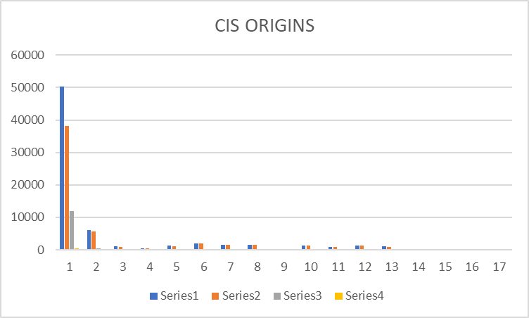

Activation Orders: WASS1133 Originated by CIS

WASS1133 Service Orders

ORIGINATING CIS | TOTAL | PERCENTAGE | COMPLETE | FAILED | TIMEOUT
CIS_JAMAICA | 20497 | 71.53% | 14755 | 3667 | 2075
CIS_CAYMAN | 0 | 0.00% | 0 | 0 | 0
CIS_ANTIGUA | 86 | 0.30% | 9 | 77 | 0
CIS_ANGUILLA | 336 | 1.17% | 245 | 91 | 0
CIS_BARBADOS | 0 | 0.00% | 0 | 0 | 0
CIS_BVI | 1648 | 5.75% | 876 | 772 | 0
CIS_DOMINICA | 259 | 0.90% | 136 | 122 | 1
CIS_GRENADA | 2570 | 8.97% | 2414 | 154 | 2
CIS_MNI | 31 | 0.11% | 29 | 1 | 1
CIS_SANTA_LUCIA | 845 | 2.95% | 800 | 18 | 27
CIS_ST_KITTS | 1486 | 5.19% | 1385 | 101 | 0
CIS_SN_VINCENT | 790 | 2.76% | 675 | 115 | 0
CIS_TKI | 86 | 0.30% | 46 | 38 | 2
OCA | 9 | 0.03% | 7 | 2 | 0
INTEGSSOFT | 0 | 0.00% | 0 | 0 | 0
CIS_172_21_64_99 | 11 | 0.04% | 8 | 3 | 0
ASAP TEST | 60 | 0.21% | -47 | 0 | 2108
 | 28654 |  | 21432 | 5161 | 0

Activation Orders Origin Distribution

